Data scrapping

Following the guide here using web scrapper in conjunction with Chrome:

<https://www.scrapehero.com/amazon-review-scraper/>

on 2/28/19

item 1:

All-new Echo Show (2nd Gen) – Premium sound and a vibrant 10.1” HD screen - Charcoal

<https://www.amazon.com/dp/B077SXWSRP/ref=fs_ods_bp>



Downloaded 2555 reviews (but only 2049)

https://www.amazon.com/All-new-Echo-Show-2nd-Gen/product-reviews/B077SXWSRP/ref=cm_cr_dp_d_show_all_top?ie=UTF8&reviewerType=all_reviews

item 2:

# Echo Spot - Smart Alarm Clock with Alexa - Black

[https://www.amazon.com/dp/B073SQYXTW/ref=fs_ods_rk](https://www.amazon.com/dp/B073SQYXTW/ref=fs_ods_rk#)

Downloaded 8634 reviews (but 2488 only 1st try, 4001 2nd try)

<https://www.amazon.com/Echo-Spot-Smart-Alarm-Clock/product-reviews/B073SQYXTW/ref=cm_cr_dp_d_show_all_top?ie=UTF8&reviewerType=all_reviews>

item3:

# Echo Show - 1st Generation Black

<https://www.amazon.com/dp/B01J24C0TI/ref=sr_1_6?keywords=echo+1st+generation&qid=1551337950&s=amazon-devices&sr=1-6>



Downloaded 17575 reviews (but 4001)

https://www.amazon.com/Echo-Show-1st-Generation-Black/product-reviews/B01J24C0TI/ref=cm_cr_dp_d_show_all_top?ie=UTF8&reviewerType=all_reviews

item4:

# Echo Plus with built-in Hub 1st Generation – Black

https://www.amazon.com/dp/B015S1SWLO/ref=sr_1_7?keywords=echo+1st+generation&qid=1551337950&s=amazon-devices&sr=1-7

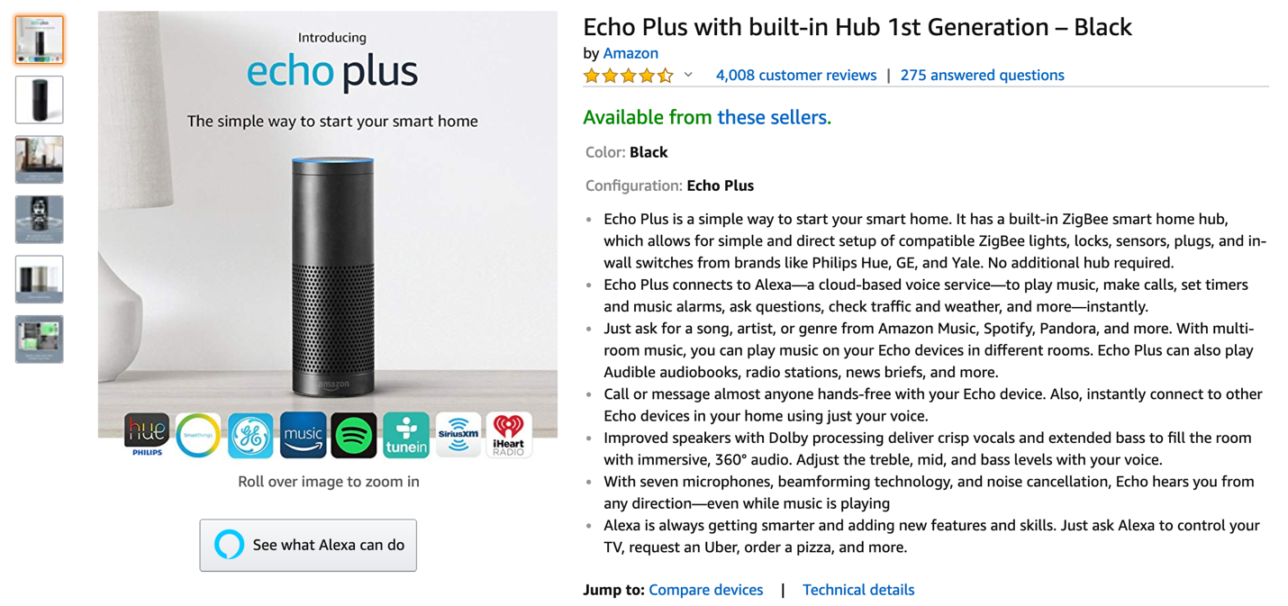

Downloaded 4008 reviews (but got 3209)

<https://www.amazon.com/Echo-Plus-built-Hub-Generation/product-reviews/B015S1SWLO/ref=cm_cr_dp_d_show_all_top?ie=UTF8&reviewerType=all_reviews>

item 5:

# All-new Echo Plus (2nd Gen) Bundle with Philips Hue Bulb - Charcoal

<https://www.amazon.com/dp/B07H1QBW2L/ref=fs_ods_aucc_ld?th=1>

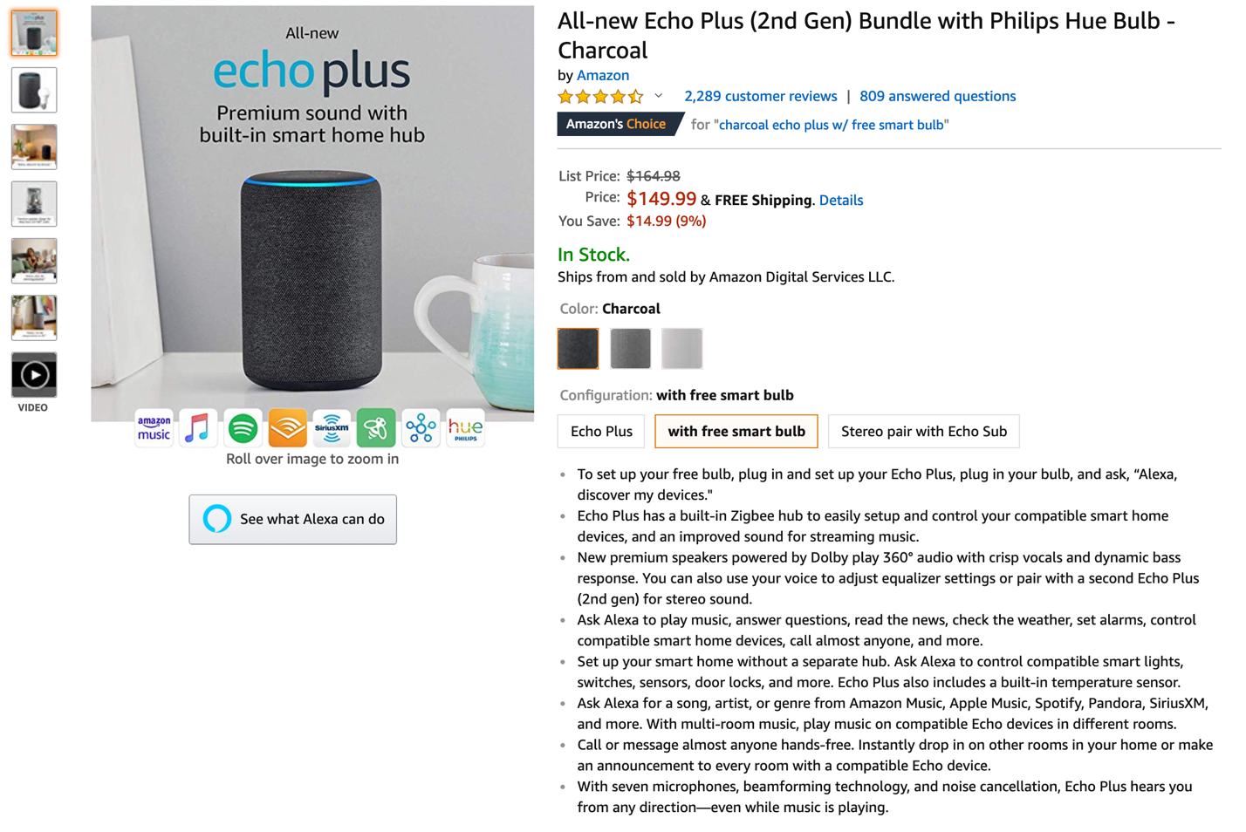

Downloaded 2279 reviews (downloaded 1841)

<https://www.amazon.com/All-new-Echo-Plus-Bundle-Philips/product-reviews/B07H1QBW2L/ref=cm_cr_dp_d_show_all_top?ie=UTF8&reviewerType=all_reviews>